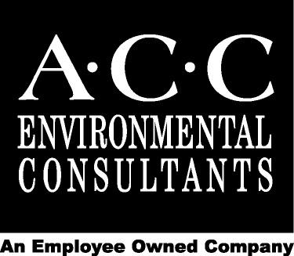

Service – Experience – Excellence

Statement of Qualifications
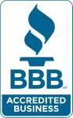
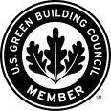

Table of Contents
ACC ENVIRONMENTAL CONSULTANTS, INC. 3
I. ASBESTOS CONSULTING 5
II. LEAD-BASED PAINT AND PCB CONSULTING 8
III. INDOOR ENVIRONMENTAL QUALITY, MOISTURE INTRUSION & MOLD 10
IV. INDUSTRIAL HYGIENE/ SAFETY 11
Expert Witness 11
Contractor Health and Safety Support Services 11
Exposure Assessments 12
Concrete Moisture Testing 12
V. Silica Dust Control and Compliance Plan 13
VI. ENVIRONMENTAL SITE ASSESSMENTS/ SUBSURFACE CHARACTERIZATION 14
VII. SOIL AND GROUNDWATER INVESTIGATION AND MANAGEMENT 16
VIII. UNDERGROUND STORAGE TANKS (UST) 17
IX. LEED PROJECT TESTING AND CERTIFICATION 18
X. TRAINING SERVICES 19
Asbestos Courses 19
Lead Courses 19
Water Intrusion & Mold Courses 20
Silica Training 20
REPRESENTATIVE CLIENT LIST 21

ACC ENVIRONMENTAL CONSULTANTS, INC.

Established in 1986, ACC Environmental Consultants, Inc. (ACC) is an employee-owned full service environmental consulting and design firm recognized for its excellent and reliable client service.

ACC’s mission is to assist in the management of environmental and health & safety issues for corporations, state and local governments, universities, school districts, hospitals, housing authorities, residential developers, financial and insurance firms, research and bio-tech facilities and manufacturers. We work to provide sound, timely and cost-effective solutions to meet our clients’ goals by facilitating the management of liabilities and regulations and maintaining a suitable working environment.

ACC maintains one of the most qualified and experienced staffs in the state and our experience in large-scale community sensitive projects is deep and on going. We utilize project management best practices, state of the art equipment and our own innovative data gathering software systems to assist our clients in accomplishing their near and long-term hazardous materials and industrial hygiene compliance programs goals.

ACC’s Staff Includes:
- Professional Geologists
- Environmental Site Assessors
- Industrial Hygienists
- Indoor Air Quality Specialists
- Certified Asbestos Professionals
- Certified Lead-based Paint Professionals
- Certified Hazardous Materials Managers

Our Core Services Include:
- Asbestos and Lead-Based Paint Testing and Consulting
- Silica Dust Monitoring and Exposure Control Plans
- Industrial Hygiene Services
- Indoor Environmental Quality Testing and Consulting
- LEED Environmental Testing and Certification
- Water Intrusion and Mold Inspections
- OSHA Employee Training - Asbestos, Lead-Based Paint, Silica and Mold
- Phase I: Environmental Site Assessments (ESA)
- Phase II: Soil and Groundwater Investigation
- Underground Storage Tank Consulting
- Hazardous Chemical Materials Inventory Management and Business Plans
- Environmental Information Management System (ADAM)
- Employee Information Management System (SMART)

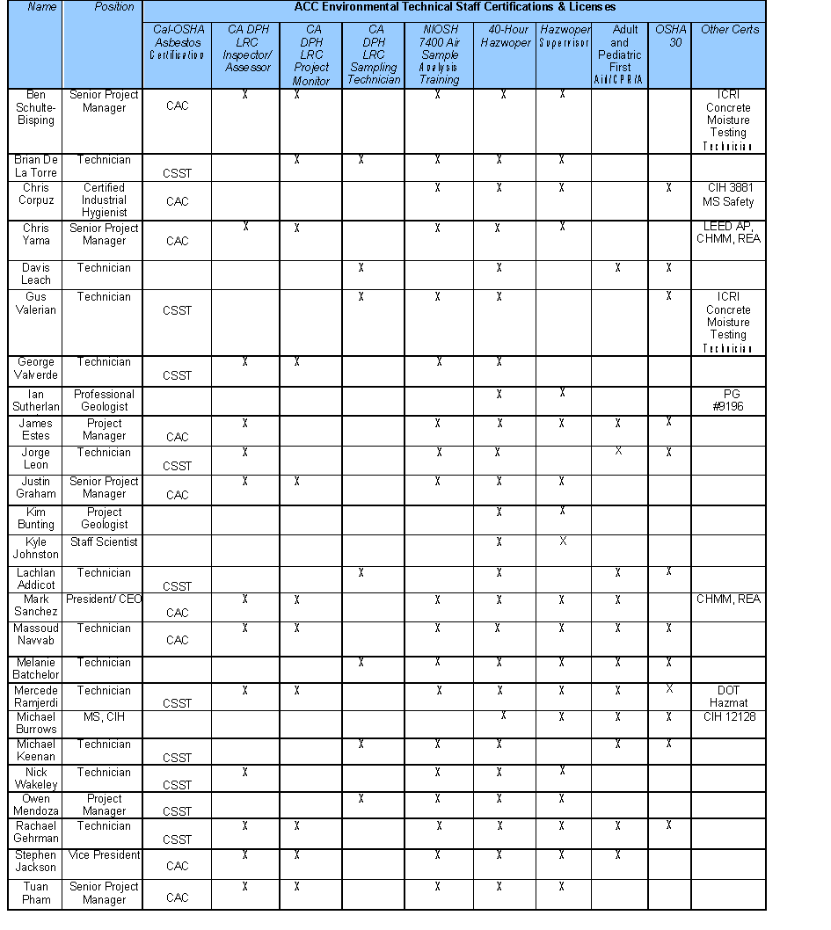
I. ASBESTOS CONSULTING

State and federal regulations hold building owners and employers responsible for protecting employees, occupants, and outside contractors from exposure to asbestos. ACC assists our clients by working with them to understand the regulatory requirements pertinent to their property and to develop programs to ensure their compliance with regulations.

Our clients are confident that the projects we manage are delivered on time and on budget and are executed with the highest standard of safety and care.
ACC is a leader in providing asbestos consulting, abatement design and project management throughout the State of California. ACC's asbestos team, comprised of California Certified Asbestos Consultants and California Site Surveillance Technicians, has performed thousands of projects involving the identification of hazardous materials and abatement oversight of materials prior to a demolition or renovation project.
Asbestos Service Includes

- Comprehensive and Limited Asbestos Surveys
- Work Plans, Design/Specifications and Bidding Assistance
- Abatement Project Management and Monitoring
- Asbestos Operations and Maintenance Plans
- ADAM Environmental Information Management Software System
- Asbestos Training

Total Asbestos Management (TAM)

ACC developed TAM as a full-service asbestos management and regulatory compliance program developed to assist building and facility managers in complying with various asbestos regulations in a timely and technical matter.

Using the TAM program approach, ACC’s trained asbestos professionals address all asbestos management, emergency response, and regulatory compliance issues that confront building managers.

The TAM program includes:

- Performing building surveys or reviewing and updating previous survey reports
- Using the ACC developed software program ADAM™ to prepare reports, notifications, and forms, and track abatement and asbestos management activities
- Preparing asbestos notifications for building tenants, contractors, and employees
- Providing OSHA compliant 4-hour asbestos awareness and 8-to-16-hour operations and maintenance training
- Posting site-specific asbestos warning signs in routine maintenance areas
- Preparing an asbestos program manual (O&M) for the building that includes:
- Description of material locations
- Management and emergency response procedures and safe work practices
- Sample notifications and distribution guidelines
- Building-specific asbestos warning signs for posting in maintenance areas
- Training materials and information
- Recordkeeping forms

Building Surveys and Material Sampling

Federal, State, and Local regulations call for asbestos surveys to be performed for a variety of reasons:

- Construction and Renovation: Prior to renovation projects or demolition projects.
- Due diligence: For property transactions prior to purchase or sale.
- Health and Safety: Notification to employees, occupants and vendors in buildings.

ACC provides quality survey reports that clearly detail the description, location, quantity and condition of each material identified and sampled. A thorough and complete inventory of all asbestos containing materials is created for each survey area, allowing building owners and employers to meet their notification requirements.

Abatement Design and Bidding Assistance:

Our Project Managers are among the most experienced designers and project managers in the field. We use our abilities and insights in assisting our clients in obtaining the best and most cost-efficient bids from our list of pre-screened contractors.

ACC’s design specifications are comprehensive and clearly written using the most current and safe methods to protect the needs of our clients and obtain the most cost-efficient bids from qualified abatement contractors.

Abatement Project Management and Air Monitoring

Our project managers are committed to the principal of responsibility for the successful completion of the projects they manage. Our field staff is highly trained to actively monitor the activities of abatement contractors at all levels of abatement. ACC has developed state-of-the-art project management tools specific to asbestos abatement that assist in ensuring that all critical elements of the work are observed and documented.

OSHA Training Programs

ACC’s team of asbestos professionals offers OSHA-required courses for all employees who work around or may disturb asbestos-containing materials and lead-based paint in the course of their work. Our courses are designed to protect worker and occupant health and safety; reducing the liabilities posed by asbestos containing materials.

Asbestos courses offered by ACC include:

- Class IV OSHA and AHERA Awareness Training, designed for construction, engineering, and maintenance personnel who work around and contact asbestos-containing materials, but with no disturbance.
- Class III OSHA Operations and Maintenance Training, designed for employees required to clean up small asbestos spills and repair damaged materials under the supervision of an OSHA Class III Supervisor (Competent Person).
- Class III OSHA Supervisor Training, designed for employees who supervise Class III and IV activities.

II. LEAD-BASED PAINT AND PCB CONSULTING

ACC is an established industry leader in the field of lead-based paint testing and consulting. Our staff of California Department of Public Health (DPH) certified lead-based paint professionals have successfully completed hundreds of lead surveys and removal projects. Our knowledge of the regulations as well as our depth of experience working with qualified contractors allows us to maintain a reputation as one of the top consulting companies in the field.

Lead-Based Paint Services Include:
- Building Surveys and Testing
- Risk Assessments
- HUD Lead Surveys and Testing
- Work Plans, Design/Specifications and Bidding Assistance
- Abatement Project Management and Monitoring
- Operations and Maintenance Plans
- ADAM Environmental Information Management Software System

Lead-Based Paint Courses offered by ACC include:
- EPA Lead Renovation, Repair and Painting (RRP) Training (Initial and Refresher)
- Lead Awareness Training
- Lead Procedures Training

Polychlorinated Biphenyls (PCB) Sampling:
In 2012, ACC was tasked to develop a Hazardous Materials Abatement Oversight and Monitoring Plan for a large-scale implosion project at a California State University. The building had a high quantity of PCB containing material and soil contamination became a big concern. During this project ACC worked with the EPA and other regulating agencies to develop state of the art practices to manage PCB contamination during demolition and renovation projects.

PCBs are mixtures of synthetic organic chemicals with the same basic chemical structure and similar physical properties ranging from oily liquids to waxy solids. Due to their non-flammability, chemical stability, high boiling point and electrical insulating properties, PCBs were used in hundreds of industrial and commercial applications including electrical, heat transfer, and hydraulic equipment; as plasticizers in paints, plastics and rubber products; in pigments, dyes and carbonless copy paper and many other applications. More than 1.5 billion pounds of PCBs were manufactured in the United States prior to cessation of production in 1977.

PCBs have been demonstrated to cause a variety of adverse health effects, including cancer in animals. PCBs have also been shown to cause a number of serious non-cancer health effects in animals, including effects on the immune system, reproductive system, nervous system, endocrine system and other health effects. Studies in humans provide supportive evidence for potential carcinogenic and non-carcinogenic effects of PCBs. The different health effects of PCBs may be interrelated, as alterations in one system may have significant implications for the other systems of the body.

The proper identification and handling of PCB-contaminated equipment and wastes is critical to the prevention of future waste management problems. All equipment or waste containing PCBs should be properly labeled, alerting people to the requirement for special handling procedures. While procedures may vary depending on the industry or specific operation, as a general rule, any time there is a risk of contact with PCBs, appropriate protective equipment should be worn to limit contact with the skin and eyes and to protect against inhalation of PCB fumes. Such equipment may include plastic or rubber gloves, boots, overalls, aprons, face shields or self-contained breathing apparatus. For workers cleaning up a major spill containing high concentrations of PCBs, a full suit of non-porous material should be worn. Clothing that has become contaminated should be disposed of along with other PCB wastes.

PCB manufacture, use, storage and disposal are regulated by U.S. EPA under TSCA and Part 761, Title 40 of the Code of Federal Regulations (40 CFR Part 761). TSCA regulates any materials or wastes that contain PCBs at concentrations of 50 ppm (parts per million) or greater. PCB wastes are also regulated as hazardous waste by DTSC under the Health and Safety Code (HSC) and Title 22 of the California Code of Regulations (22 CCR).

Criteria for determining PCB wastes are:
- Total threshold limit concentration (TTLC) of 50 ppm of PCBs, and/or
- Soluble threshold limit concentration (STLC) of 5 ppm of PCBs as oily liquid.

PCB Services Include:
- Building Surveys and Testing
- Risk Assessments
- Work Plans, Design/Specifications and Bidding Assistance
- Abatement Project Management and Monitoring
- Operations and Maintenance Plans
- ADAM Environmental Information Management Software System

III. INDOOR ENVIRONMENTAL QUALITY, MOISTURE INTRUSION & MOLD

ACC performs indoor environmental quality evaluations in all types of buildings and occupational settings. ACC utilizes the latest sampling and analytical equipment to determine if contaminants that cause indoor air and environmental quality (IEQ) issues including carbon monoxide, volatile organic compounds (VOCs), formaldehyde, fungal spores and particulates are present at levels that can cause problems for inhabitants.

Indoor Environmental Quality Services Include:
- Baseline Indoor Environmental Quality (IEQ) Studies & Sampling
- LEED Environmental Testing and Certification
- Construction Dust Control Planning
- HVAC Evaluations
- Moisture Intrusion Assessments and Infrared Imaging
- Remediation Design and Management
- Proactive IEQ Prevention Programs and Training
ACC provides complete IEQ investigations, abatement design and management services, contractor bid coordination, project management and air monitoring to ensure all contaminants are removed and the area is prepared for restoration.

ACC routinely works with property owners and managers to develop IEQ prevention programs and provide training to their employees on how to identify and respond to issues, including water intrusion and moisture problems in a timely manner. The training also covers the personal protective equipment and procedures to be followed to control potential problems in buildings.

ACC’s clients can be assured of obtaining unbiased and cost-effective recommendations in our IEQ investigations, project designs, and management of remediation projects.

IV. INDUSTRIAL HYGIENE/ SAFETY

Expert Witness
ACC provides Certified Industrial Hygienist Expert Witness and Litigation
Support on a wide variety or EH&S issues. ACC Expert Witness services include:

- Technical Review
- Safety Compliance
- Occupational Chemical Exposure
- IEQ
- Industrial Hygiene Studies
- Case preparation
- Deposition
- Testifying at Trial

Contractor Health and Safety Support Services
ACC has the experienced staff personnel to assist all contractor levels in designing, implementing, maintaining, and auditing the following contractor health and safety services:

Contractor safety services include:

- Workplace and process hazard assessments
- Employee exposure assessments
- Workplace monitoring
- Hazardous chemical and agent monitoring
- OSHA-compliant safety and health program development and evaluation
- OSHA-compliant program maintenance
- Workplace safety and health hazard assessments
- Certified health and safety professionals
- Bi-lingual training
- Onsite safety and health training
- Selection and use of Personal Protective Equipment
- OSHA expert witness
- Safety staffing solutions
- Supervisor and Competent Person training
- Presentations and speaking engagements
- Implementation and management of federal and state programs
- Developing and implementing Health and Safety Plans

Exposure Assessments
Radon
Occupational/ Community Noise
Ionizing/ non-ionizing Radiation
Silica

Concrete Moisture Testing
Moisture-related floor covering failures are responsible for over $1 billion annually in damages. The problems range from cupping, buckling, blistering and adhesive failure to discoloration, IAQ issues and mold growth. These issues can occur soon after the installation, and in some cases years down the road. Additionally, moisture testing of slabs is a key component of many manufacturers warranty requirements.
Concrete Moisture Testing Includes:
Two of the more common moisture testing methods in use today when installing resilient flooring are:
- Anhydrous calcium chloride test (ASTM F710 standard)
- Direct reading relative humidity probe (ASTM F2170 standard)
The relative humidity probe measurements are quickly becoming the state-of-the-art for investigations, but it is important to review the manufacturer’s recommendation on which standard is recognized for warranty purposes. ACC is equipped to perform both types of testing.

V. Silica Dust Control and Compliance Plan

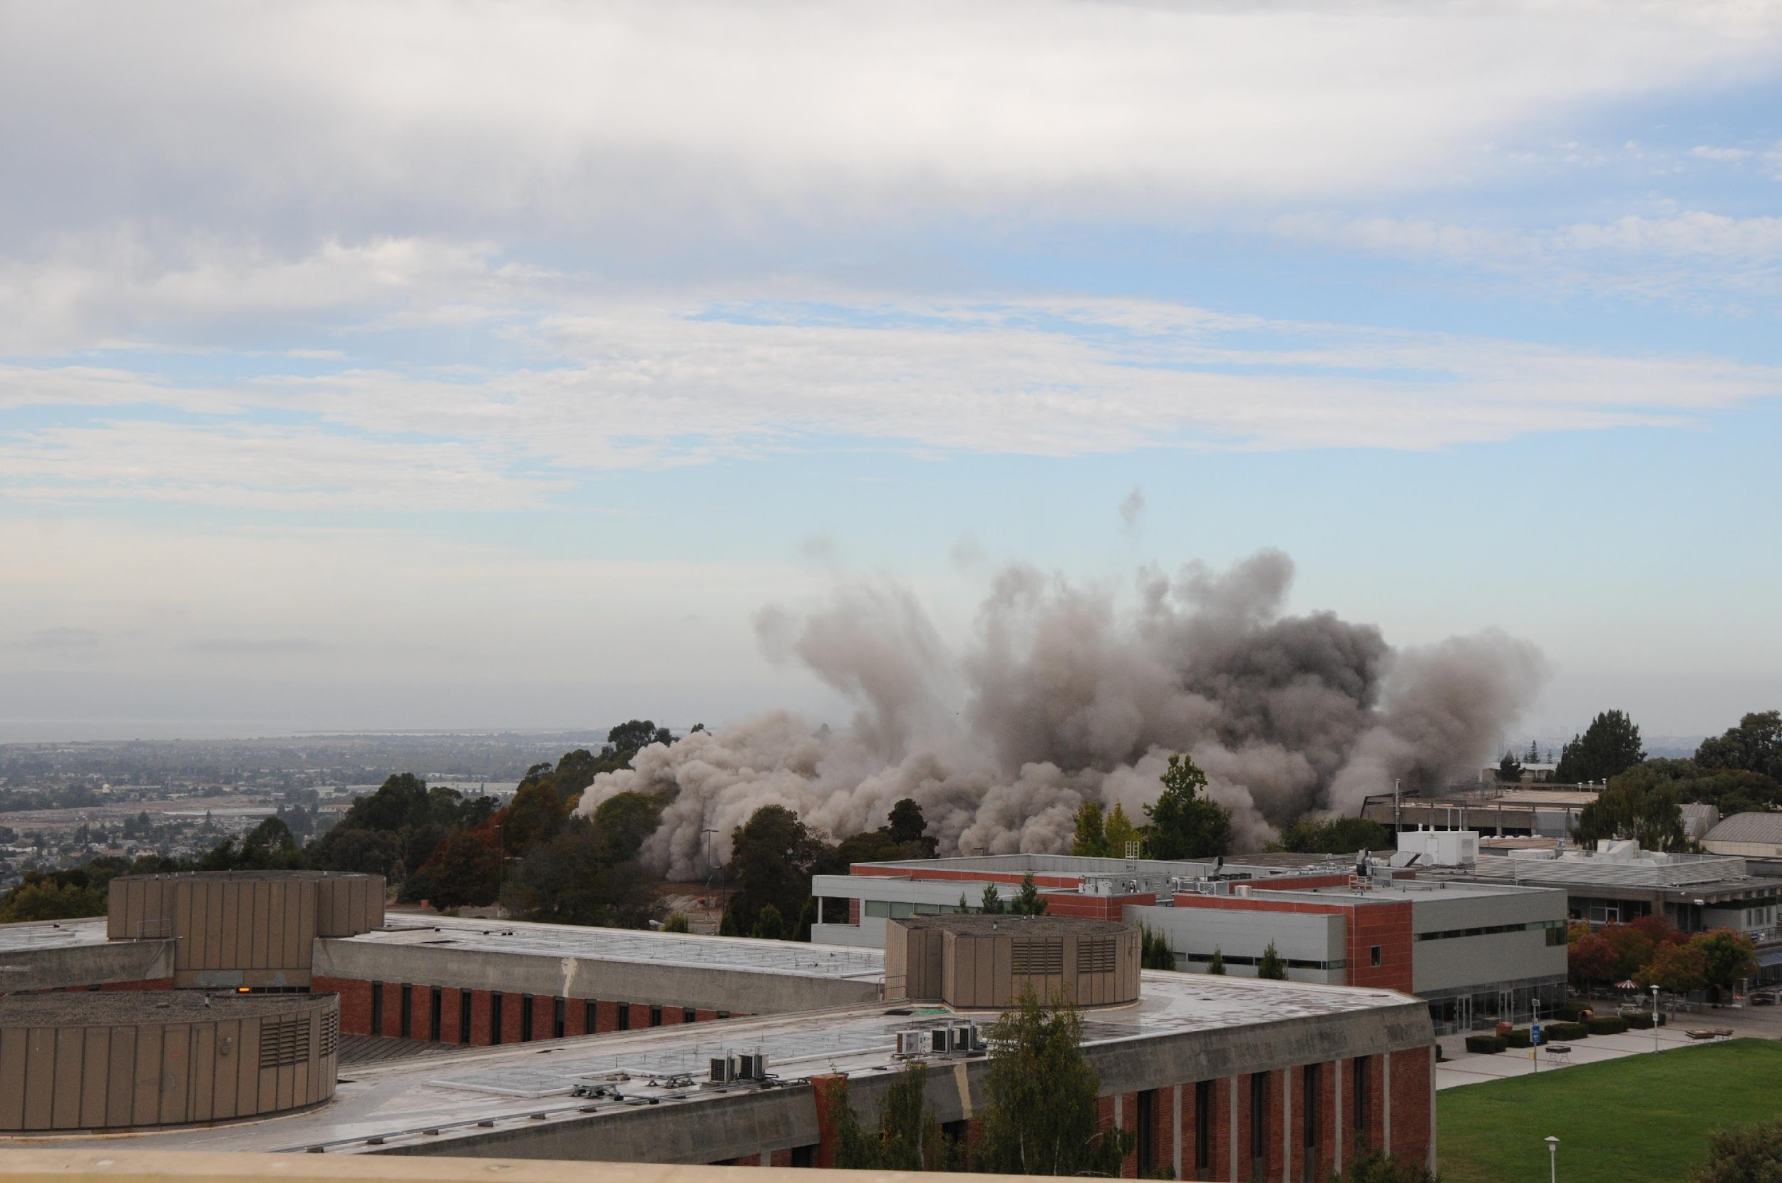

The Occupational Safety and Health Administration (OSHA) Respirable Crystalline Silica Dust Construction Standard went into effect on September 23, 2017.

The standard requires employers to limit worker exposures to respirable crystalline silica and take steps to protect workers through training and engineering/work practice methods to control dust emissions.

Silica's main components include Quartz, Cristobalite and Tridymite. It is one of the most common minerals in earth's crust and is a major component of sand, quartz, rock and mineral ores. Making it a common component of job site dust.

Silica Dust Control and Compliance Plan Includes:
- Development and Implementation of the Exposure Control Plan
- Employee Silica Training
- Jobsite Silica Dust Oversight and Monitoring

The final rule includes a reduced airborne respirable crystalline silica Action Level (AL) of 25 µg/m³ and a Permissible Exposure Limit (PEL) of 50 μg/m³, calculated as an 8-hour time-weighted average (TWA), as well as additional training and engineering/work practice control methods requirements. ACC is available to assist through every stage to ensure full compliance to this new Standard.

VI. ENVIRONMENTAL SITE ASSESSMENTS/ SUBSURFACE CHARACTERIZATION

ACC works on behalf of all parties in real estate transactions including; buyers, sellers, investors, and lenders. To ensure our work meets the highest standards, ACC follows the industry recognized ASTM guidelines and the Federal EPA All Appropriate Inquiry (AAI) standard. We understand the importance of helping the deal come together and strive to determine “real” environmental concerns and not raise red flags or where issues can be resolved in the Phase I ESA process.
As a result, only 15% of our Phase I site assessments end up requiring additional sampling or Phase II work. As one of the leading environmental consulting firms in California, ACC can provide the quick turn-around that is often required during the due diligence period of a real estate transaction.

Phase I ESA Includes
- Records Review
  - Environmental Database Search
  - Regulatory Agency Records Review
  - Historical Document Review (Historical Aerial Photographs, Topographic Maps, Sanborn Maps, City Directories, Title Reports and Other Land Use Records
  - Geologic and Hydrogeology Review
  - Site Reconnaissance
  - Interior and Exterior site walk through
  - Interviews
  - Phase I ESA User
  - Owners, Property Managers, and Occupants
  - All knowable Parties
  - Government Agencies
  - Non-Scope Additional Considerations
  - Lead
  - Asbestos
  - Radon
  - Polychlorinated biphenyl’s (PCBs) (light ballasts & electrical) transformers
  - Electronic PDF Reporting
  - A digital report summarizing all findings, with color photos, and color site maps.
  - Phase II Environmental Site Assessments
Subsurface Characterization Services include:
- Phase II / Subsurface Soil Boring Investigations
- Soil Vapor Surveys
- Site Contaminant Modeling
- Groundwater Monitoring Well Installation, Sampling & Destruction
- Regulatory Agency Interaction / Negotiation
- Electronic Reporting / GeoTracker Compliance

ACC initially utilizes Geoprobe® technology to obtain samples to properly characterize subsurface conditions, enabling our professionals to determine the extent and levels of contaminants present and to develop the most effective methods to remediate the site.

Phase II Environmental Site Assessments
The purpose of a Phase II Environmental Site Assessment is to determine the presence, likely presence, or absence of substances (constituents of concern) in environmental media including; soil, soil vapor, groundwater, surface water, and indoor air. Phase IIs are typically conducted as a result of Recognized Environmental Conditions identified in a Phase I ESA.
Phase II ESAs assist our clients in evaluating potential environmental risks, health risks, financial risks, and potential liability associated with these risks based on our clients needs and potential uses of the Site.

Phase II ESA (May Include Some Or All Of The Following Services)
- Sampling of Environmental Media
- Soil Boring Investigation
- Soil Sampling
- Soil Vapor/Soil Gas Sampling
- Groundwater Sampling
- Sampling of building materials

ACC has over 30 years of experience performing site characterization for soil and groundwater. ACC works on our client’s behalf to determine the most cost-effective approach for each investigation while focusing only on the constituents of concern and the ability to interact with overseeing regulatory agencies progressively.

VII. SOIL AND GROUNDWATER INVESTIGATION AND MANAGEMENT

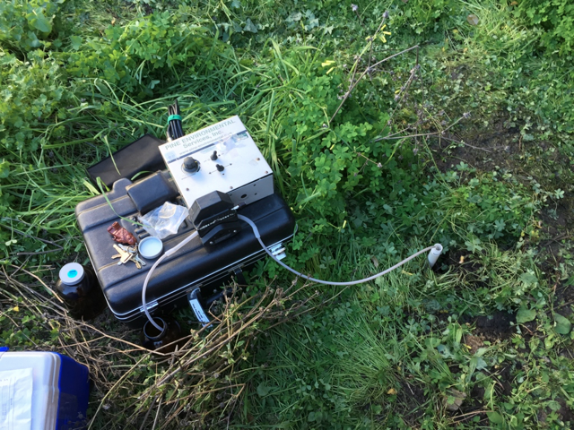

ACC has professional knowledge and expertise to provide our clients with cost-effective remediation strategies for sites with soil and groundwater contamination.

ACC manages all aspects of remediation projects, from developing Corrective Action Plans (CAPs) and Remedial Action Plans (RAPs) approved by overseeing regulatory agencies, implementing various contaminant removal remedies, including: soil excavation, groundwater extraction, and soil vapor extraction (SVE), conducting onsite in-situ treatment methods such as activated-carbon, internal combustion engine (ICE), catalytic oxidizer (CatOx), and use of oxygen releasing compound (ORC®).

Soil and Groundwater Remediation Services include:
- Site Characterization
- Soil and Groundwater Profiling for Disposal and/or Re-use Purposes
- Short and Long Term Groundwater Sampling and Monitoring
- Soil Excavation Oversight and Soil Off-Haul for Large Scale Projects
- Groundwater Monitoring Well Installation
- Regulatory Agency Interaction
- Site Case Closure
- Heath and Safety Plans
- Site Mitigation Plans
- Soil Management Plans
- Maher Ordinance Compliance
- Dust Monitoring

ACC works with experienced contractors to design, construct and implement remediation projects within established timeframes, budgets and regulatory requirements.

ACC also develops and provides oversight for implementation of Soil Management Plans (SMPs) and Health & Safety Plans (HSPs).

VIII. UNDERGROUND STORAGE TANKS (UST)

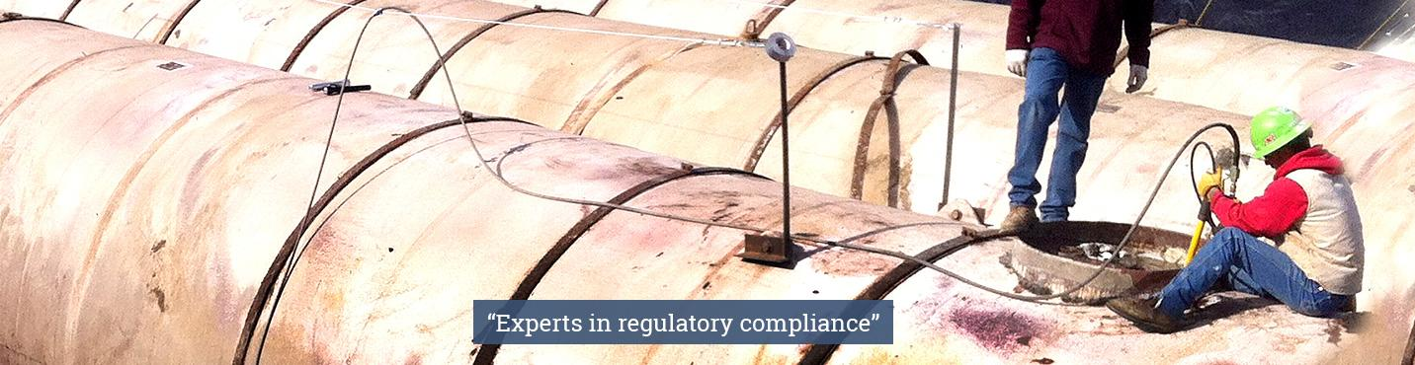

ACC has managed the removal of underground storage tanks and associated contamination at hundreds of sites throughout California. Current regulations require underground storage tanks that do not meet current requirements be removed and any associated contamination exceeding regulatory levels be remediated.

Storage Tanks
ACC provides Aboveground and Underground Storage Tank Removal Specifications and Project Management. ACC works on our client’s behalf to handle all aspects of tank removal projects. This includes:
- Preparation of removal specifications
- Obtaining competitive bids from qualified tank removal contractors
- Obtaining required permits
- Agency interaction
- Managing contractor activities
- Performing required sampling of soil and groundwater
- Removal/closure reporting

Leaking Storage Tank Assessment And Soil Sampling
ACC provides tank assessments from leak discovery to case closure.
Services includes:
- Source and site characterization services
  - Site Characterization and Assessment
  - Field Sampling
  - Determining constituents of concern
  - Determining applicable cleanup criteria
- Site Assessments
  - Field Sampling
  - Installation of groundwater monitoring wells, soil vapor/gas wells
  - Monitoring (soil, soil vapor/gas, and groundwater sampling)
- Corrective Action
  - Soil and groundwater treatment system design and installation services
  - Long term groundwater monitoring services
  - Treatment systems operations and maintenance
  - Over-excavation of contaminated soil
  - Site Closure
  - Risk Assessments
  - Site Conceptual Modeling
  - Well Abandonment
  - Documenting, Reporting, and Certifying Closure

IX. LEED PROJECT TESTING AND CERTIFICATION

LEED certification provides independent, third-party verification that a building project meets the highest green building and performance measures. As members of the U.S. Green Building Council (USGBC), we take great pride in helping our clients’ take more environmentally sound steps to better their own business and becoming more energy efficient and achieve green project goals. As many businesses now are becoming more environmentally conscious and LEED requirements becoming commonplace in local building codes, ACC is there to help our clients in their effort to become LEED compliant.

LEED Services Include:
- IAQ/IEQ Testing
- Hazardous Material Survey and Management
- Construction IAQ Management Plan and Development
- IAQ Compliant Product Consulting
- Construction Dust Mitigation Planning
- Recycling Program Management
- Construction Waste Management
- Post Flush-out/Pre-occupancy Air Testing
- Brownfield Redevelopment Assistance

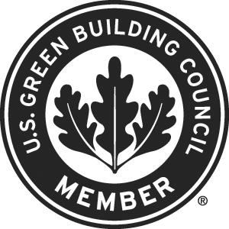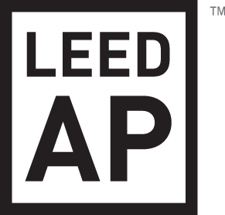

X. TRAINING SERVICES

ACC offers OSHA required training for owners, supervisors and workers who work with or around asbestos and lead-containing materials, and in environments where water intrusion and mold may be encountered. Our courses are designed to protect building owners, managers, occupants and worker’s health and safety while reducing liabilities posed by exposure to hazardous and regulated materials.

ACC offers highly informative, hands-on classes that teach attendees proper procedures for working with and around asbestos, lead and mold from experts who have over 120 years of combined real-world knowledge and expertise. All of ACC’s training courses are designed to meet or exceed the requirements of Federal and California OSHA regulations and industry standards.

ACC provides regularly scheduled classes occurring throughout the year, with current schedule and enrollment information on our accenv.com web site. Accommodations for special training requirements and on-site training is available.

ACC can also provide short or focused briefings on asbestos, lead, mold, hazard communication, silica, LEED Indoor Environmental Quality, and environmental site assessment topics to your organization to enhance your understanding of current issues and improve project performance.

Asbestos Courses
- OSHA Class IV Awareness Training, designed for construction, engineering, and maintenance personnel who work around and contact asbestos-containing materials, but with no disturbance.
- OSHA Class III Operations and Maintenance Training, designed for employees required to clean up small asbestos spills and repair damaged materials under the supervision of an OSHA Class III Supervisor (Competent Person).
- OSHA Class III Supervisor Training, designed for employees who supervise Class III and IV activities.

Lead Courses
- OSHA Lead Awareness Training, designed for maintenance personnel to learn proper work practices to prevent potential disturbance to lead-containing materials and prevent exposure to workers and building occupants.
- Lead Procedures Training, designed for compliance with the OSHA Lead-in-Construction Standard where workers disturb lead-containing materials during maintenance, construction or renovation activities.

EPA Lead Renovation, Repair And Painting (RRP) Initial (8-Hour Course) & Refresher (4-Hour Course)
- This 8-hour course trains renovation, repair and painting contractors how to work safely in housing with lead-based paint and comply with EPA’s Renovation, Repair and Painting (RRP) Rule and HUD’s Lead Safe Housing Rule. Includes health effects, regulations, lead-safe work practices, interior and exterior containment, cleaning and waste removal, record-keeping, training non-certified renovation workers, hands-on training, review and examination.
- Who Should Attend: Contractors who work in pre-1978 housing and who might disturb painted surfaces while doing plumbing, electrical, drywall, painting, tile, window replacement, landscaping, repairs, construction, renovation, remodeling, HVAC, demolition, plus many, other jobs. The RRP rule applies to people who are contractors, handymen, maintenance companies, rental property owners, schools, and day care providers as well as non-profits and government agencies.

Water Intrusion & Mold Courses
- Mold Prevention & Management, designed to help building owners and maintenance personnel reduce potential mold exposure from past water intrusion events and to proactively handle water intrusion events to prevent or minimize mold from developing.

Silica Training
- Silica Training, designed for employers and workers who work with or around concrete or masonry materials during dry mixing, use of power tools during cutting, grinding, coring and drilling operations for compliance with OSHA’s Silica Standard.

REPRESENTATIVE CLIENT LIST

Partial Public Agency and Education Client List (Partial List)

- University of California Davis  - Oakland Housing Authority  - Oakland Unified School District  - County of San Mateo  - Chabot College  - Peralta Community College  - City of Hayward  - City of Newark  - City of Oakland  - City of San Leandro  - Livermore Valley School District  - Alameda Unified School District  - County of Alameda  - Cal State University East Bay | - County of Alameda  - City of Fremont  - San Jose State  - Port of Oakland  - Los Angeles County Development Commission and Housing Authority of the County of Los Angeles  - Los Angeles Unified School District  - Los Angeles County Public Administrator  - City of Santa Monica  - Los Angeles County Department of Public Works  - Hayward Area Recreation Department
Real Estate Management Groups, Contractors and Developers
(Partial List)

- GCI General Contractors  - The Swig Company, LLC  - Novo Construction  - NVS  - Regis Homes Bay Area, LLC  - Related California  - SC Builders  - Transwestern  - Clark Construction Group  - Macy’s Inc.  - Cushman and Wakefield  - BRCP  - Ellis Partners  - CBRE  - Prometheus  - Alamo Drafthouse  - Mosaic Urban Development  - S101 Management  - Genentech  - Novartis  - Nibbi Construction | - China Basin Landing  - Colliers International  - Hines  - Jamison Properties  - McMorgan & Company  - Peter Sullivan Associates  - The DeSilva Group  - Transamerica Real Estate  - Unico Properties  - Village Properties  - Legacy Partners  - Bridge Housing Corporation  - Bently Holdings  - East Bay Asian Local Development Agency  - EAH Housing, Inc.  - Navtech Group  - DPR Construction  - Salvation Army  - C. Overaa & Co (Chevron)  - Pacific Development, LLC

Other Notable Client Groups
Financial Institutions
Lenders and Brokers
Hospitals
Architects and Engineering firms

Public Agencies
Cities
Counties
Housing Authorities
State and Federal Agencies
Transit Authorities
Municipal Utility Districts
Ports

Education
Universities (Public and Private)
Community College Districts
K-12 Unified School Districts
Charter and Private School Districts

Service – Experience – Excellence

